Jiao et al. BMC Biology
(2025) 23:229
https://doi.org/10.1186/s12915-025-02329-1
BMC Biology
Open Access
METHODOLOGY
Integration of pre-trained protein language
models with equivariant graph neural networks
for peptide toxicity prediction
Shihu Jiao^{1,2}, Xiucai Ye^{2*}, Tetsuya Sakurai², Quan Zou^{1,3}, Wu Han^{4*} and Chao Zhan^{5*}
Abstract
Background Peptide-based therapeutics have great potential due to their versatility, high speciﬁcity, and suitability
for a variety of therapeutic applications. Despite these advantages, the inherent toxicities of some peptides pose
challenges in drug development. Several computational methods have been developed to allow rapid and eﬃcient
large-scale screening of peptide toxicity. However, these methods mainly rely on the primary sequence and often
ignore critical structural information, which limits their predictive accuracy.
Results In this study, we introduce a novel framework named StrucToxNet that integrates a pre-trained protein
language model with an equivariant graph neural network to improve peptide toxicity prediction. By combining
sequence embeddings from the ProtT5 language model and 3D structural data predicted by ESMFold, StrucToxNet
can capture both sequential and spatial characteristics of peptides. Testing on the independent dataset indicates
that StrucToxNet outperforms existing sequence-based models in various metrics, achieving higher balanced accu-
racy and overall performance.
Conclusions The results demonstrate the robustness and generalizability of StrucToxNet, marking it a reliable tool
in the computational screening of toxic peptides and facilitating safer peptide-based drug development.
Keywords Peptides, Toxicity, Structure, Protein language model, Equivariant graph neural networks
Background
Peptides are short chains of amino acids linked by pep-
tide bonds, and they are ubiquitous in a wide variety of
organisms, from simple microorganisms to complex mul-
*
Correspondence:
Xiucai Ye
yexiucai@cs.tsukuba.ac.jp
Wu Han
kevinwh@stanford.edu
Chao Zhan
ticellular life forms [1]. Peptides can be derived from a
range of natural sources, such as venoms, food products,
and marine organisms [2–5]. ey may also be synthe-
sized chemically or produced by recombinant techniques
zhanchaoHMU@proton.me
[
6]. ese molecules often fold into secondary structures,
1
Yangtze Delta Region Institute (Quzhou), University of Electronic Science
and Technology of China, Quzhou, China
Department of Computer Science, University of Tsukuba,
Tsukuba 3058577, Japan
Institute of Fundamental and Frontier Sciences, University of Electronic
Science and Technology of China, Chengdu, China
Department of Statistics, Stanford University, 100 Inﬁnity Way, Mountain
View, CA 94043, USA
Harbin Medical University Cancer Hospital, Harbin 150001, China
such as α-helices and β-sheets, and can also assemble
into even more complex structures [7–10]. Compared
with traditional small molecule drugs, peptide drugs have
unique advantages, such as higher selectivity and aﬃnity,
fewer side eﬀects, and better biocompatibility [6, 11]. A
well-known example is insulin, a peptide hormone used
in the treatment of diabetes. ese inherent advantages
2
3
4
5
©
The Author(s) 2025. Open Access This article is licensed under a Creative Commons Attribution-NonCommercial-NoDerivatives 4.0
International License, which permits any non-commercial use, sharing, distribution and reproduction in any medium or format, as long
as you give appropriate credit to the original author(s) and the source, provide a link to the Creative Commons licence, and indicate if
you modiﬁed the licensed material.You do not have permission under this licence to share adapted material derived from this article or
parts of it.The images or other third party material in this article are included in the article’s Creative Commons licence, unless indicated
otherwise in a credit line to the material. If material is not included in the article’s Creative Commons licence and your intended use is not
permitted by statutory regulation or exceeds the permitted use, you will need to obtain permission directly from the copyright holder.To
view a copy of this licence, visit http://creativecommons.org/licenses/by-nc-nd/4.0/.


Jiao et al. BMC Biology
(2025) 23:229
Page 2 of 10
make them an ideal choice for various therapeutic appli-
cations, including anti-bacterial, anti-cancer, anti-angio-
genic, and immunomodulatory eﬀects [12–15].
structural and sequence representations for accurate
peptide toxicity prediction. Due to the lack of experi-
mentally determined 3D structures, we use ESMFold
to predict the structures of all peptides due to its rapid
processing speed and high accuracy [33]. StrucToxNet
is built on an E(3) EGNN architecture that incorpo-
rates symmetry-aware graph convolutions, allowing it
to handle transformations involving translation, rota-
tion, and reﬂection in 3D space [38]. Inspired by the
notable successes of PLMs, we integrate embeddings
from the widely used ProtT5-XL-U50 (ProtT5) to
reﬁne the sequence-based node features in the EGNN
framework [39]. We demonstrate that StrucToxNet
outperforms state-of-the-art (SOTA) sequence-based
methods in predicting peptide toxicity. By leveraging
both sequence and structure, our approach can capture
a more comprehensive representation, thereby improv-
ing the performance of the model).
However, despite their therapeutic promise, some
peptides exhibit inherent toxicities, with documented
cytotoxic, tissue-damaging, and neurotoxic proper-
ties [16, 17]. erefore, identifying and mitigating such
toxic eﬀects is crucial for advancing peptide-based
therapeutics [18, 19]. e evaluation of peptide toxicity
in biomedical experimental settings demands complex
experimental design, rigorous conditions, and lengthy
screening cycles, which limits large-scale screening.
Computational approaches are an eﬀective solution
because they have the potential to perform large-scale
preliminary screening before clinical trials [20–26]. In
recent years, several deep learning prediction tools have
been developed to identify protein and peptide toxic-
ity. Typical examples include ToxinPred series [17, 27],
CSM-Toxin [28] and ATSE [29]. While these methods
have successfully used 1D residue sequences for toxic-
ity prediction, they often overlook the explicit modeling
of structural information. Yet, it is well established that
the 3D conformation of proteins and peptides is key to
determining their diverse biological functions and phys-
icochemical properties [30]. Recent advances in struc-
tural biology, particularly in computational methods like
RoseTTAFold, ESMFold, and AlphaFold2, have made it
faster and easier to obtain reliable structural data [31–
Results
Comparative performance with existing methods
In this section, we evaluate StrucToxNet on the test
dataset and compare its performance with ﬁve SOTA
methods, including three general methods for proteins
and peptides (CSM-Toxin, ToxinPred2 and ToxinPred3)
and two methods speciﬁcally designed for peptides
(ToxIBTL and CAPTP). All of these compared methods
are sequence-based, and the results are summarized in
Table 1. StrucToxNet shows signiﬁcant improvements
in key metrics, with a BACC increase of 1.6% and an SP
increase of 2.2% compared to the second-ranked model
CAPTP. In addition, the AUC score of StrucToxNet
improved by 0.9%, and its average precision (AP)
increased by 1.1% (Fig. 2A, B). is demonstrates that
incorporating structural information has a clear advan-
tage in improving performance compared to sequence-
only models.
3
4]. Studies have shown that predicted protein structures
are highly valuable for related tasks, including protein–
nucleic acid binding site prediction, identiﬁcation of
antimicrobial peptides, and B-cell epitopes prediction
[
35–37]. is provides an opportunity to enhance the
performance of toxicity prediction by leveraging pre-
dicted structural information.
In this study, we integrate a protein large language
model (PLM) with an equivariant graph neural network
(EGNN) and propose a novel predictor named Struc-
ToxNet. As shown in Fig. 1, StrucToxNet leverages
Fig. 1 Framework of StrucToxNet for peptide toxicity prediction
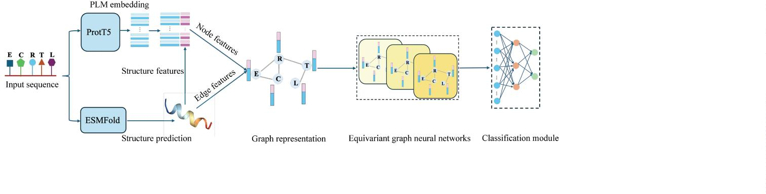

Jiao et al. BMC Biology
(2025) 23:229
Page 3 of 10
Table 1 Comparison of StrucToxNet and existing methods using the independent test dataset
Model
Type
BACC (%)
AUC
SN (%)
SP (%)
MCC
CSM-Toxin
ToxinPred2
ToxinPred3
ToxIBTL
protein
protein
protein
peptide
peptide
peptide
47.81
64.22
85.57
91.56
91.59
93.18
0.400
0.874
0.926
0.916
0.959
0.968
4.06
91.56
32.51
88.96
91.56
92.56
94.79
−0.076
0.299
0.692
0.803
0.811
0.852
95.94
82.19
91.56
90.63
91.56
CAPTP
StrucToxNet
Fig. 2 ROC curves (A) and precision–recall curves (B) for the compared methods. t-SNE visualizations of the feature spaces learned by StrucToxNet
(C), ProtT5 encoding (D), the CNN model (E), and the LSTM model (F)
Comparison with other sequence‑based methods
prediction. is is also a standard approach in protein-
related tasks and has achieved good results. e results
are summarized in Table 2.
To comprehensively evaluate the performance of Struc-
ToxNet, we compare it with other sequence-based
approaches, including traditional classiﬁers and neu-
ral network-based models. In this analysis, the protein
language model ProtT5 is used as a feature extractor
to generate sequence embeddings. ese embeddings
are subsequently processed by either traditional classi-
ﬁers or neural network architectures. Traditional clas-
siﬁers directly use the pooled sequence embeddings for
training, while neural networks including convolutional
neural networks (CNN) and long short-term mem-
ory networks (LSTM) further extract meaningful pat-
terns and capture sequence features relevant to toxicity
e results in Table 2 show that StrucToxNet outper-
forms both traditional classiﬁers and neural network
models across multiple evaluation metrics. While some
traditional classiﬁer-based models, such as LightGBM
and XGBoost, achieve high AUC scores comparable to
StrucToxNet and show strong SP, they do not reach the
same levels of BACC or MCC. All neural network mod-
els achieve more balanced performance with high SN,
BACC, and MCC, demonstrating their ability to further
learn and extract useful information from the original
ProtT5 embeddings. Overall, StrucToxNet maintains
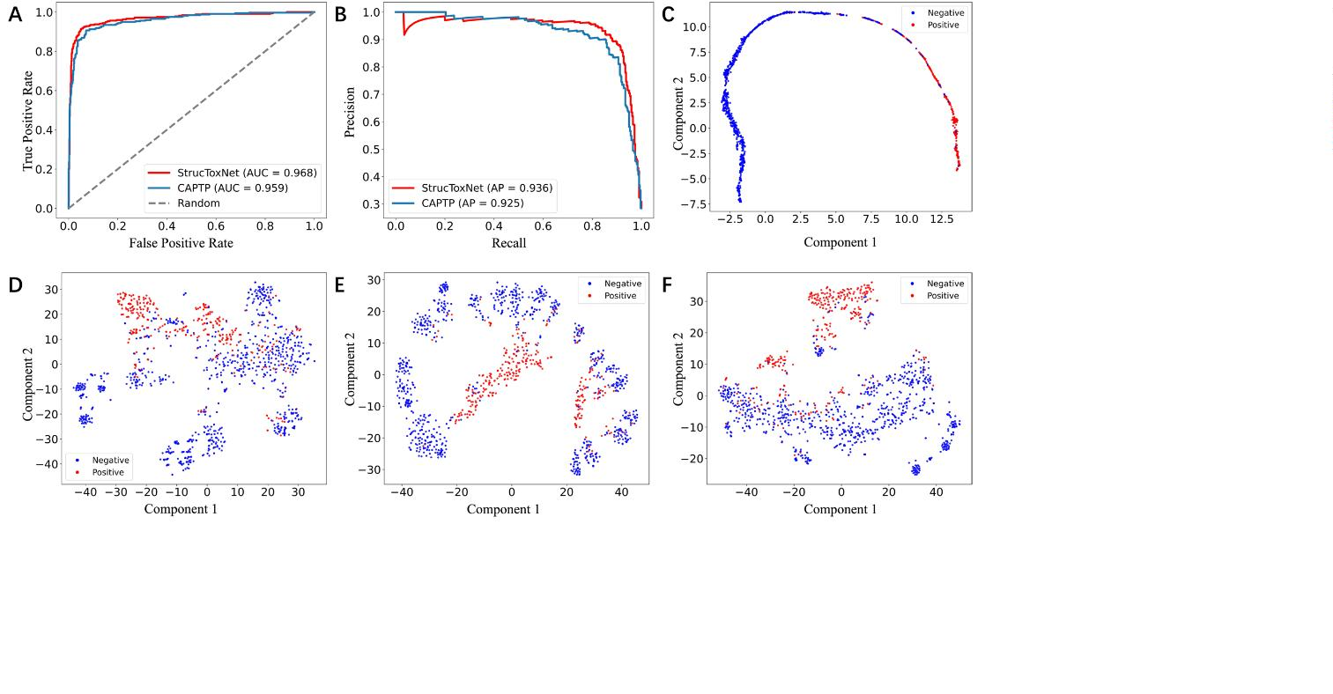

Jiao et al. BMC Biology
(2025) 23:229
Page 4 of 10
Table 2 Comparison of StrucToxNet and other sequence-based methods on the independent test dataset
Model
BACC (%)
AUC
SN (%)
SP (%)
MCC
RF
85.70
89.29
87.92
87.26
91.52
91.03
93.18
0.954
0.970
0.971
0.958
0.961
0.968
0.968
73.75
80.94
79.06
78.12
89.38
88.75
91.56
97.64
97.64
96.77
96.40
93.67
93.30
94.79
0.769
0.822
0.792
0.779
0.818
0.807
0.852
XGBoost
LightGBM
SVM
CNN
LSTM
StrucToxNet
more consistent performance on all metrics, demonstrat-
ing the advantage of incorporating structural information
for toxicity prediction tasks.
Conﬁdence distribution analysis
We further compare these models using conﬁdence dis-
tribution analysis, which evaluates the certainty of pre-
dictions. Figure 3C, F shows the prediction conﬁdence
distribution of diﬀerent models for correctly predicted
positive and negative samples. StrucToxNet shows high
conﬁdence in its predictions for both positive and nega-
tive samples, with a peak near high conﬁdence scores. In
contrast, other models exhibit more uncertainty in one or
both classes, as seen in their broader distribution across
lower conﬁdence levels. StrucToxNet also shows a lower
density in the mid-conﬁdence range, indicating greater
certainty in its predictions. ese results indicate that
StrucToxNet consistently produces more conﬁdent pre-
dictions, demonstrating its reliability and robustness in
predicting peptide toxicity.
To further analyze the feature representations learned
by StrucToxNet, we apply t-SNE to visualize the feature
space learned by these models. Figure 2C–F shows the
resulting plots, where each point represents a peptide.
In the original ProtT5 embedding space, there is moder-
ate separation between two classes with some overlap,
suggesting that there is room for improvement. Struc-
ToxNet achieves the clearest separation between classes,
indicating that it can eﬀectively extract discriminative
information from the original ProtT5 embeddings. In
comparison, embeddings learned by other neural net-
works show further separation of samples relative to
ProtT5 but do not achieve the same clarity as Struc-
ToxNet. ese results demonstrate the eﬀectiveness and
robustness of StrucToxNet.
Ablation study
To evaluate the relative contribution of each core com-
ponent of StrucToxNet, we perform an ablation study by
excluding each part from the full architecture on the test
data. To evaluate the impact of using PLM embeddings
as node features, we replace them with one-hot encoding
to obtain amino acid-level sequence-based features (w/o
PLM). We also study the contributions of structural fea-
tures (w/o Structure) and contrastive learning (w/o CL).
Table 3 shows the performance of these variants of Struc-
ToxNet on the test metrics.
Peptide length range analysis
To investigate the impact of peptide length on predictor
performance, we compare the misclassiﬁcation rates of
various predictors on toxic and non-toxic peptides across
a range of lengths using the independent test set. e
results are shown in Fig. 3A, B. For toxic peptides, deep
learning models generally perform better across all pep-
tide length ranges, with StrucToxNet achieving the best
performance in each range. In contrast, machine learn-
ing models perform poorly for most peptide lengths,
with particularly high misclassiﬁcation rates for shorter
sequences. For non-toxic peptides, machine learning
models perform well across all length ranges. Interest-
ingly, deep learning models tend to have higher misclas-
siﬁcation rates for mid-length sequences. StrucToxNet
shows comparable performance to the best-performing
models across a wide range of peptide lengths. Consider-
ing results from both positive and negative samples, our
model consistently shows stable and competitive per-
formance, making it a reliable choice for a wide range of
peptide lengths.
As shown in Table 3, removing the PLM embeddings
led to a decrease of 4.3% in BACC and 9.7% in MCC.
is change indicates that the ProtT5 embeddings can
capture important sequence information for our predic-
tion. Excluding structural features slightly lowered BACC
and MCC, indicating that structural information also
contributes positively to model performance. Finally, the
contrastive learning helps balance the model and thus
improves the overall performance. In summary, the full
model achieves the highest scores across all metrics, con-
ﬁrming that each component contributes to the overall
predictive performance.

Jiao et al. BMC Biology
(2025) 23:229
Page 5 of 10
Fig. 3 Heat maps showing misclassiﬁcation rates across diﬀerent peptide length ranges for positive (A) and negative (B) samples. Density
of positive (C) and negative (D) samples at varying prediction conﬁdence levels. Distribution of pLDDT scores in the training and test sets,
before and after removal of low-quality samples (E). Comparison of model performance trained on samples with diﬀerent structure prediction
qualities (F)
Eﬀect of the quality of predicted structure
Table 3 The performance of StrucToxNet when removing each
Given that our model relies heavily on peptide struc-
tures predicted by ESMFold, it is important to evaluate
how the quality of these predictions aﬀects peptide tox-
icity prediction outcomes. Structural predictions could
introduce errors, and low-conﬁdence predictions may
negatively impact model performance. ESMFold provides
a conﬁdence metric called predicted local distance diﬀer-
ence test (pLDDT) for each predicted structure (Fig. 3E).
core module
Model
BACC (%)
AUC
SN (%)
SP (%)
MCC
w/o PLM
88.88
0.940
0.966
0.965
0.968
87.19
90.94
87.81
91.56
90.57
94.67
95.16
94.79
0.755
0.845
0.830
0.852
w/o Structure 92.80
w/o CL
91.49
93.18
StrucToxNet

e pLDDT score ranges from 0 to 100, where higher
scores indicate greater conﬁdence in the accuracy of the
predicted structure. To investigate the impact of struc-
ture prediction conﬁdence on model performance, we
ﬁltered out samples with pLDDT scores below 60 and
retrained the model on this reﬁned dataset. As shown
in Fig. 3F, key metrics such as BACC, AUC, and MCC
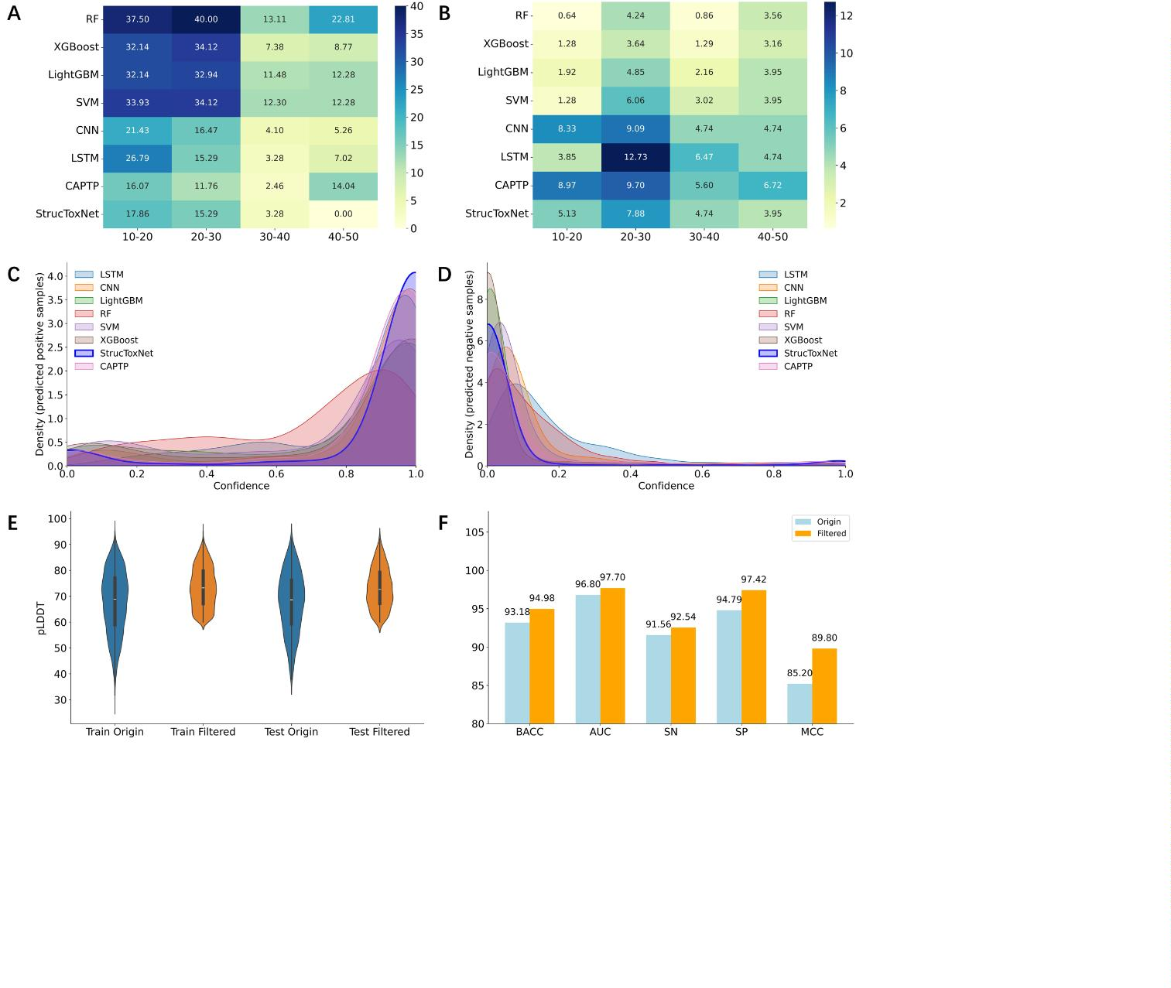

Jiao et al. BMC Biology
(2025) 23:229
Page 6 of 10
have all improved, with BACC reaching 94.98% and AUC
improving to 0.977. is improvement demonstrates the
importance of reliable structural data for improving pre-
diction accuracy. e performance of the model could
improve even more if high-conﬁdence structures from
experiments are available.
methods. Performance analysis demonstrates the robust-
ness and generality of StrucToxNet, especially in handling
unbalanced datasets and providing reliable predictions
across diﬀerent peptide lengths. Furthermore, we dem-
onstrate the potential of further improving the accuracy
of toxicity predictions when more accurate experimental
structural data become available by analyzing the impact
of structure prediction quality. Overall, these results
demonstrate the potential of incorporating structural
context into peptide-level tasks and provide a promising
direction for developing safer peptide-based therapeutics
through computational screening.
Discussion
Identifying toxic peptides is an essential step for guid-
ing safe drug development and therapeutic applications.
Previous computational tools for peptide toxicity pre-
diction are mainly sequence-based models that rely on
contextual features from sequential neighbors, although
some have attempted to capture long-range interactions
using various techniques. e proposed StrucToxNet
framework demonstrates superior performance over
traditional sequence-based approaches across various
metrics. Despite these promising results, there are sev-
eral limitations worth considering. First, StrucToxNet
relies on structures predicted by ESMFold, which may
introduce inaccuracies, especially for short and ﬂex-
ible peptides. e improved performance after ﬁltering
low-conﬁdence structures demonstrates that the model
depends on the accuracy of predicted conformations.
Incorporating multiple predicted conformations or lev-
eraging experimentally determined structures where
available could potentially improve robustness and
reduce structural bias. Second, the current framework is
designed for linear peptides. Many therapeutic peptides
are cyclic or undergo post-translational modiﬁcations,
which are not captured by the current model. Extend-
ing StrucToxNet to include cyclic peptides or modiﬁed
residues would improve its applicability in drug discovery
scenarios. ird, the model currently provides general
toxicity classiﬁcation without considering speciﬁc toxic
mechanisms such as hemolytic, immunotoxic, or neuro-
toxic eﬀects. Future work could integrate toxicity subtype
annotations and develop multi-task learning architec-
tures that simultaneously predict toxicity type and sever-
ity. Lastly, the current model still functions as a black-box
model. Enhancing the transparency of the model through
attention-based visualization or explainable AI tech-
niques could help uncover the biochemical and structural
features associated with peptide toxicity.
Methods
Datasets and performance evaluation
e main peptide dataset utilized for training and the
independent test dataset employed are sourced from
the previous CAPTP work [40]. In brief, peptides with
toxicity are considered as ToxPs, whereas those without
known toxic activity are non-ToxPs. e training dataset
contains 1818 ToxPs and 4569 non-ToxPs, with an inde-
pendent test set of 320 ToxPs and 806 non-ToxPs.
e datasets used here have an unbalanced distri-
bution of positive and negative samples. To conduct a
comprehensive evaluation of the proposed model, we
employed a set of evaluation metrics, including balanced
accuracy (BACC), sensitivity (SN), speciﬁcity (SP), Mat-
thews correlation coeﬃcient (MCC), area under the pre-
cision-recall curve (AUPRC) and area under the receiver
operating characteristic curve (AUC). ese metrics are
all widely used in biological sequence analysis tasks [41,
42]. e deﬁnitions and formulas of these metrics are as
follows:
TP
(1)
SN =
TP + FN
TN
(2)
(3)
(4)
SP =
TN + FP
1
BACC = (SN + SP)
2
TP × TN − FP × FN
(TP + FP)(TP + FN)(TN + FP)(TN + FN)
MCC = √
Conclusions
where true positives (TP) represent samples correctly
predicted as positive, while true negatives (TN) indi-
cate samples correctly predicted as negative. False posi-
tives (FP) are samples incorrectly predicted as positive,
and false negatives (FN) are samples incorrectly labeled
as negative. Here, SN measures the model’s ability to
In this work, we propose a novel structure-based
framework for peptide toxicity prediction by explicitly
incorporating structural data and modeling spatial rela-
tionships. By combining 3D structural information pre-
dicted by ESMFold alongside sequence embeddings from
ProtT5, our model outperforms existing sequence-based

Jiao et al. BMC Biology
(2025) 23:229
Page 7 of 10
identify positive samples, while SP measures its ability to
identify negative samples. e remaining metrics provide
an assessment of the model’s overall performance.
what is known as the structure. A residue includes ele-
ments like an amino group, a carboxylic acid group, and a
side chain group that deﬁnes its type. ese components
connect to a central carbon atom known as the Cα. Fol-
lowing previous studies and for simplicity, we use only
the Cα to represent the main backbone structure of each
Overview framework of StrucToxNet
As shown in Fig. 1, StrucToxNet combines the pre-
dicted structure with the information from the pre-
trained language model. e peptide sequence is input
into ESMFold and ProtT5 simultaneously: ESMFold
generates the peptide structure from which the cor-
responding structural features are extracted, while
ProtT5 generates the node embeddings. ese struc-
ture-based features and node embeddings are then
combined to form the ﬁnal node features. e resulting
structures are represented as 3D graphs, where nodes
represent residue information and edges deﬁne the spa-
tial relationships between them. EGNN is subsequently
employed to update the node representations and coor-
dinates. Finally, a prediction module is used to deter-
mine whether the input sequence is toxic. To address
class imbalance, a contrastive learning strategy is also
incorporated following the CAPTP framework. e
StrucToxNet model was implemented using PyTorch
(v2.4.1) and the PyTorch Geometric (PyG) library
(v2.6.1). e training was conducted on an NVIDIA
A100 GPU for up to 200 epochs. Hyperparameter
optimization was performed using ﬁvefold cross-vali-
dation on the training set, and the search space along
with the selected optimal conﬁguration is summarized
in Additional ﬁle 1: Table S1. For a fair comparison,
all baseline models were trained using the same set of
hyperparameters.
peptide [43]. For sequence
with the 3D coordinates of
P
all Cα
x ∈ R
n×³, two residues and are considered to
i
j
be in contact if the Euclidean distance
d_{ij}
between their
corresponding Cα atoms falls within 8 Å. In this case,
the structure of a peptide is deﬁned as a residue-level
graph
G = (V, E)
, where
E
V
represents the residues in the
sequence , and
P
represents the edges between resi-
dues, with each edge connecting two residues that are in
contact.
Node feature generation
For each residue in the predicted structures, we extracted
two types of features: sequence-based and structure-
based node features. e sequence-based features are
embeddings from a protein large language model, while
the structure-based features capture key physicochemical
and geometric properties of each residue. By combining
these two types of features, we create the ﬁnal node fea-
ture set of the model.
Language model representation
We choose ProtT5 as the feature extractor to gener-
ate residue embeddings as one type of node feature [39,
44]. ProtT5 is a powerful tool for extracting meaningful
sequence features from peptides, capturing the complex
biophysical and biochemical properties of residues. It
was pretrained on a large corpus of protein sequences
in a self-supervised fashion and has been shown to cap-
ture some of the “grammar” behind the language of life
encoded in protein sequences. For given input peptide
Peptide structure prediction
To capture the geometric properties of each amino acid,
we utilized esmfold_v1 (ESMFold) to predict the struc-
ture for each peptide [33]. Unlike traditional methods,
ESMFold does not rely on multiple sequence alignment
(MSA) or complex evolutionary data. Instead, it uses
a large protein language model, trained on millions of
protein sequences, combined with an end-to-end neural
network to directly infer protein structure. is enables
ESMFold to provide atomic-level structure predictions at
high speed. It is 60% faster than AlphaFold2 while main-
taining similar accuracy. is speed advantage makes
ESMFold particularly useful for predicting the structures
of our entire peptide dataset mentioned above.
sequence
P = (p , p , . . . , p )
of length , ProtT5 use its
1
2
n
encoder to generate a context-aware embedding matrix
of shape
n × 1024
, as shown in formula (5). To avoid
massive activations, the embedding values are then nor-
malized to a range between 0 and 1 using formula (6).
h = ProtT5Encoder(P)
(5)
^{x − x}min
x′ =
(6)
x_{max} − x_{min}
where ProtT5Encoder refers to the encoder of ProtT5
that processes the input sequence without additional
ﬁne-tuning, with h representing the embedding matrix
Graph construction
it generates.
represents the original value in gener-
and x are the minimum and

e speciﬁc arrangement of residues determines the 3D
ated embeddings, x
min
max
positions of all the atoms within the peptide, forming
maximum values of that feature type in the training set,

Jiao et al. BMC Biology
(2025) 23:229
Page 8 of 10
Table 4 Summary of structure-based node features
Feature
Description
Dimension
Secondary structure
Encodes both 3-state and 8-state secondary structures using one-hot encoding
11
10
Relative solvent accessibility
One-hot encoding is applied to both 2-state and 8-state relative solvent accessibility (RSA) features.
For the 2-state RSA, a threshold of 50 is used to distinguish between states. For a more detailed
representation, the 8-state RSA features are encoded with RSA values divided into eight discrete bins:
0
–30, 30–60, 60–90, 90–120, 120–150, 150–180, 180–210, and>210
Local geometric
Sine and cosine values of backbone torsion angles (α, Φ, Ψ), normalized virtual bond and torsion angles,
and the normalized tetrahedral geometry derived from the N, Cα, and C atoms of the residues
14
Residue orientation
Unit vectors pointing towards the directions of Ca
− Ca and Ca
(i−1)
− Ca for residue i .
6
1
1
(i−1)
i
i
Relative sequence position
Relative spatial position
Inverse of the sequence position of the residues
Inverse of the Euclidean distance between the Cα atom of the residue and the centroid of the entire
structure
Virtual surface area
Contact count
Inverse of the virtual convex hull surface area of each amino acid residue, where the hull is formed
by its constituent atoms
1
1
Normalized number of spatial neighbors of each residue, where two residues are considered in contact
if the Euclidean distance between their Cβ atoms is<8 Å
respectively. is normalization ensures consistent scal-
ing of embedding values across the dataset.
does not rely on expensive spherical harmonics [38].
EGNN has been shown to be able to eﬀectively capture
and model complex spatial relationships and has already
been successfully applied to similar tasks. e EGNN
framework consists of a stack of equivariant graph con-
volutional layers (EGCL), with each layer updating the
coordinates and node features by integrating edge infor-
mation along with the coordinates and node features
from the previous layer. e initial node features are ﬁrst
linearly transformed to produce a set of node embed-
dings. ese transformed embeddings, along with edge
information and the coordinates, are then fed into the
subsequent EGCL layers for updating. e StrucToxNet
architecture consists of three stacked EGCL layers, each
with a hidden dimension of 256. In particular, each EGCL
layer updates both the node embeddings and coordinates
as deﬁned below:
Structure‑based node feature generation
We use a variety of structure-based node features to
capture the geometric and spatial properties from the
predicted structures. ese features include: (1) sec-
ondary structures; (2) relative solvent accessibility; (3)
local geometric features; (4) residue orientation; (5)
relative sequence position; (6) relative spatial position;
(7) virtual surface area; and (8) residue contact count.
A detailed description of these features is provided in
Table 4. Together, these structural feature vectors form a
4
5-dimensional feature set.
Edge and coordinate feature generation
For edge features in the graph G = (V, E), we compute
the Euclidean distance in 3D space between residue pairs
i and j, deﬁned as d = �x − x � . ese scalar distances
l
i
l
j
(7)
^{m}ij ^{= φ} h , h , e
e
ij
ij
i
j
2
are then transformed into informative edge representa-
tion vectors using a Gaussian radial basis function (RBF),
resulting in edge features e . is mapping captures the
ꢀꢁ
ꢂ
ꢄ
x_{i}^{l}+1
=
x^{l}
+
C
x^{l}
−
x^{l}
φ_{x}^{ꢃm}
ij
i
i
j
ij
(8)
spatial relationship within the graph structure in a form
j
�=i
that can be more eﬀectively utilized during message pass-
ing. In addition, the Cartesian coordinates (x y z) of Ca
atoms, which represent the spatial positions of nodes in
ꢀ
^{m}i ⁼
^{m}ij
(9)
j
�=i
3
D space, are also included as coordinate features and are
updated within StrucToxNet.
ꢀ
ꢁ
l+1
i
l
i
(10)
h
= φ_{h} h , m
i
Equivariant graph neural network module
We apply the E(3) EGNN framework to eﬀectively cap-
ture spatial information within a graph structure by
integrating both node and edge features during mes-
sage passing. EGNN is a translation, rotation, reﬂection,
and permutation equivariant graph neural network that
l m
For each layer ,
represents the message from node
ij
l
j
to node . Here, ^{l} and ^{l} are node embeddings, while
i
h
h
x
i
j
i
and ^{l} are their corresponding coordinates. e edge fea-
x
j
ture
e_{ij}
represents the edge attribute between node and
i
j
. In all equations,
φ
represents a non-linear operation

Jiao et al. BMC Biology
(2025) 23:229
Page 9 of 10
implemented through a multi-layer perceptron (MLP).
AP
RF
SVM
XGBoost
Average precision
Random forest
Support vector machine
Extreme gradient boosting

e EGCL maintains equivariance by integrating coordi-
nate updates directly into the message-passing mecha-
nism. Speciﬁcally, the update of the coordinates x^{(l}+¹⁾ for
LightGBM Light gradient boosting machine
i
CNN
LSTM
pLDDT
AI
Convolutional neural network
Long short-term memory network
Predicted local distance diﬀerence test
Artiﬁcial intelligence
node i at layer (l + 1) depends on its relative positions of
node i with respect to all other nodes. is is achieved by
ꢀ
ꢁ
summing the coordinate diﬀerences x^{l} − x^{l} for all
i
j
j = i, eﬀectively capturing the spatial context of each
Supplementary information
node within the entire structure. To normalize the impact
The online version contains supplementary material available at https://doi.
org/10.1186/s12915-025-02329-1.
of neighboring nodes, a scaling factorC =
1
is applied,
N−1
where N is the total number of nodes. In addition to
updating coordinates, the EGCL layer also aggregates
messages from neighboring nodes to update the embed-
dings. e aggregated message m for node i is obtained
Additional ﬁle 1: Table S1. Hyperparameter optimization using 5-fold cross-
validation on the training dataset.
i
by summing the pairwise messages m from all neighbor-
Acknowledgements
Not applicable.
ij
ing nodes. e update of node embedding h^{(l}+¹⁾ is based
i
on the current embedding h^{l} and the aggregated message
Authors’ contributions
i
m . By recursively updating both node embeddings and
S.J. and Q.Z. conceived and designed the experiment. S.J. and X.Y. performed
the experiment. S.J. analyzed the results. S.J. and X.Y. wrote the manuscript.
Q.Z., W.H. and T.S. reviewed and revised the manuscript. All authors read and
approved the ﬁnal manuscript.
i
coordinates layer by layer, EGNN builds a comprehensive
representation of spatial relationships.
Funding
Prediction module
This work was supported by the National Natural Science Foundation of
China (No. 62450002 and 62301368), JSPS KAKENHI (No. JP23H03411 and
JP22K12144), and JST (No. JPMJPF2017).

e ﬁnal component of StrucToxNet is an MLP referred
to as the prediction module, which receives the out-
put node embeddings from the last EGNN layer. ese
node embeddings are aggregated using max pooling to
generate a sequence-level representation. e predic-
tion module then maps the high-dimensional learned
sequence-level features into discrete class predictions,
eﬀectively serving as the decision-making component
to estimate the probability of peptide toxicity via:
Data availability
All data generated or analysed during this study are included in this published arti-
cle, its supplementary information ﬁles and publicly available repositories, which
are available in the Zenodo repository (https://zenodo.org/records/15599677) and
the GitHub repository (https://github.com/jiaoshihu/StrucToxNet).
Declarations
Ethics approval and consent to participate
Not applicable.
y′ = Sigmoid(HW + b)
(11)
where H ∈ R^{n×d} represents the output of last EGNN
layer; W ∈ R^{d×2} is a learnable weight matrix that projects
the embeddings into a two-dimensional output space;
and b ∈ R^{1×2} is the bias term. e sigmoid function then
converts the raw scores into probabilities within a range
of 0 to 1, yielding a two-dimensional matrix y′ that pro-
vides probabilistic estimates for toxicity.
Consent for publication
Not applicable.
Competing interests
The authors declare no competing interests.
Received: 16 January 2025 Accepted: 8 July 2025
Abbreviations
PLM
Protein language model
Equivariant graph neural network
State-of-the-art
EGNN
SOTA
ToxPs
References
1. Sewald N, Jakubke H-D: Peptides: chemistry and biology: John Wiley &
Sons; 2015.
Toxic peptides
non-ToxPs Non-toxic peptides
2. Lewis RJ, Garcia ML. Therapeutic potential of venom peptides. Nat Rev
Drug Discovery. 2003;2(10):790–802.
3. Udenigwe CC, Aluko RE. Food protein-derived bioactive peptides:
production, processing, and potential health beneﬁts. J Food Sci.
2012;77(1):R11–24.
4. Cunha SA, Pintado ME. Bioactive peptides derived from marine
sources: biological and functional properties. Trends Food Sci Technol.
2022;119:348–70.
5. Chen S, Qi H, Zhu X, Liu T, Fan Y, Su Q, Gong Q, Jia C, Liu T. Screening and
identiﬁcation of antimicrobial peptides from the gut microbiome of
cockroach Blattella germanica. Microbiome. 2024;12(1):272.
BACC
SN
Balanced accuracy
Sensitivity
SP
Speciﬁcity
MCC
AUPRC
AUC
MSA
RBF
Matthews correlation coeﬃcient
Area under the precision-recall curve
Area under the receiver operating characteristic curve
Multiple sequence alignment
Radial basis function
EGCL
MLP
Equivariant graph convolutional layer
Multi-layer perceptron


Jiao et al. BMC Biology
(2025) 23:229
Page 10 of 10
6
7
8
.
.
.
Muttenthaler M, King GF, Adams DJ, Alewood PF. Trends in peptide drug
discovery. Nat Rev Drug Discovery. 2021;20(4):309–25.
Chou PY, Fasman GD. Prediction of protein conformation. Biochemistry.
31. Baek M, DiMaio F, Anishchenko I, Dauparas J, Ovchinnikov S, Lee GR,
Wang J, Cong Q, Kinch LN, Schaeﬀer RD. Accurate prediction of protein
structures and interactions using a three-track neural network. Science.
2021;373(6557):871–6.
1
974;13(2):222–45.
Hu X, Liao M, Gong H, Zhang L, Cox H, Waigh TA, Lu JR. Recent advances
in short peptide self-assembly: from rational design to novel applications.
Curr Opin Colloid Interface Sci. 2020;45:1–13.
Jin J, Meng Q, Zeng M, Duan G, Wang E, Guo F: Rapid screening of multi-
point mutations for enzyme thermostability modiﬁcation tools. Fut Gener
Comput Syst Int J Escience 2024;160.
32. Jumper J, Evans R, Pritzel A, Green T, Figurnov M, Ronneberger O, Tun-
yasuvunakool K, Bates R, Žídek A, Potapenko A. Highly accurate protein
structure prediction with AlphaFold. Nature. 2021;596(7873):583–9.
33. Lin Z, Akin H, Rao R, Hie B, Zhu Z, Lu W, Smetanin N, Verkuil R, Kabeli O,
Shmueli Y. Evolutionary-scale prediction of atomic-level protein structure
with a language model. Science. 2023;379(6637):1123–30.
34. Wang R, Jiang Y, Jin J, Yin C, Yu H, Wang F, Feng J, Su R, Nakai K, Zou Q.
DeepBIO: an automated and interpretable deep-learning platform for
high-throughput biological sequence prediction, functional annotation
and visualization analysis. Nucleic Acids Res. 2023;51(7):3017–29.
35. Roche R, Moussad B, Shuvo MH, Tarafder S, Bhattacharya D. EquiPNAS:
improved protein–nucleic acid binding site prediction using protein-lan-
guage-model-informed equivariant deep graph neural networks. Nucleic
Acids Res. 2024;52(5):e27–e27.
36. Hao Y, Liu X, Fu H, Shao X, Cai W. PGAT-ABPp: harnessing protein language
models and graph attention networks for antibacterial peptide identiﬁca-
tion with remarkable accuracy. Bioinformatics 2024;40(8):btae497.
37. Zeng Y, Wei Z, Yuan Q, Chen S, Yu W, Lu Y, Gao J, Yang Y. Identifying B-cell
epitopes using AlphaFold2 predicted structures and pretrained language
model. Bioinformatics 2023;39(4):btad187.
38. Satorras VcG, Hoogeboom E, Welling M. E(n) Equivariant graph neural
networks. In: proceedings of the 38th international conference on
machine learning; proceedings of machine learning research: Edited by
Marina M, Tong Z. PMLR 2021;9323-9332.
39. Elnaggar A, Heinzinger M, Dallago C, Rehawi G, Wang Y, Jones L, Gibbs T,
Feher T, Angerer C, Steinegger M. Prottrans: toward understanding the
language of life through self-supervised learning. IEEE Trans Pattern Anal
Mach Intell. 2021;44(10):7112–27.
40. Jiao S, Ye X, Sakurai T, Zou Q, Liu R. Integrated convolution and self-
attention for improving peptide toxicity prediction. Bioinformatics
2024;40(5):btae297.
41. Zulﬁqar H, Guo Z, Ahmad RM, Ahmed Z, Cai P, Chen X, Zhang Y, Lin H,
Shi Z. Deep-STP: a deep learning-based approach to predict snake toxin
proteins by using word embeddings. Front Med. 2024;10.
42. Zou X, Ren L, Cai P, Zhang Y, Ding H, Deng K, Yu X, Lin H, Huang C.
Accurately identifying hemagglutinin using sequence information and
machine learning methods. Front Med. 2023;10:1281880.
9
1
1
.
0. Meng Q, Guo F, Wang E, Tang J. ComDock: a novel approach for protein-
protein docking with an eﬃcient fusing strategy. Comput Biol Med.
2
023;167:107660–107660.
1. Fu X, duan H, Zang X, Liu C, Li X, Zhang Q, Zhang Z, Zou Q, Cui F.
Hyb_SEnc: an antituberculosis peptide predictor based on a hybrid
feature vector and stacked ensemble learning. IEEE/ACM Transactions on
Computational Biology and Bioinformatics. 2024;1–17.
2. He W, Jiang Y, Jin J, Li Z, Zhao J, Manavalan B, Su R, Gao X, Wei L. Acceler-
ating bioactive peptide discovery via mutual information-based meta-
learning. Brief Bioinform. 2022;23(1):bbab499.
1
immunomodulatory eﬀects of food
‐
derived peptides. Food Front. 2024.
1
3. Chen K, Ma D, Yang X, Liu P, Wang J, Liao W. Clinical insights into the
1
4. Yan C, Geng A, Pan Z, Zhang Z, Cui F. MultiFeatVotPIP: a voting-based
ensemble learning framework for predicting proinﬂammatory peptides.
Brieﬁngs in Bioinformatics 2024;25(6).
15. Liu B, Gao X, Zhang H. BioSeq-Analysis2.0: an updated platform for analyzing
DNA, RNA and protein sequences at sequence level and residue level based
on machine learning approaches. Nucleic Acids Res 2019;47(20):e127.
16. Khan F, Niaz K, Abdollahi M. Toxicity of biologically active peptides
and future safety aspects: an update. Curr Drug Discov Technol.
1
2
018;15(3):236–42.
7. Sharma N, Naorem LD, Jain S, Raghava GP. ToxinPred2: an improved
method for predicting toxicity of proteins. Brieﬁngs in bioinformatics
2
022;23(5):bbac174.
1
1
8. Lin H. Artiﬁcial intelligence with great potential in medical informatics: a
brief review. Medinformatics. 2024;1(1):2–9.
9. Wei L, Hu J, Li F, Song J, Su R, Zou Q. Comparative analysis and prediction
of quorum-sensing peptides using feature representation learning and
machine learning algorithms. Brief Bioinform. 2020;21(1):106–19.
0. Zeng X, Xiang H, Yu L, Wang J, Li K, Nussinov R. Cheng FJNMI: Accurate
prediction of molecular properties and drug targets using a self-
supervised image representation learning framework. Nature Machine
Intelligence. 2022;4(11):1004–16.
1. Xiang H, Zeng L, Hou L, Li K, Fu Z, Qiu Y, Nussinov R, Hu J, Rosen-Zvi M,
Zeng XJNC. A molecular video-derived foundation model for scientiﬁc
drug discovery. Nat Commun. 2024;15(1):9696.
2. Ren S, Chen L, Hao H, Yu L. Prediction of cancer drug combinations based
on multidrug learning and cancer expression information injection. Futur
Gener Comput Syst. 2024.
3. Zhu H, Hao H, Yu L. Identiﬁcation of microbe–disease signed associations
via multi-scale variational graph autoencoder based on signed message
propagation. BMC Biol. 2024;22(1):172.
2
43. Zhang Z, Xu M, Jamasb A, Chenthamarakshan V, Lozano A, Das P, Tang J.
Protein representation learning by geometric structure pretraining. arXiv
preprint arXiv:220306125. 2022.
44. Li H, Liu B. BioSeq-Diabolo: biological sequence similarity analysis using
Diabolo. PLoS Comput Biol. 2023;19(6):e1011214.
2
2
2
Publisher’s Note
Springer Nature remains neutral with regard to jurisdictional claims in pub-
lished maps and institutional aﬃliations.
2
2
4. Yu L, Yang K, He X, Li M, Gao L, Zha Y. Repositioning linifanib as a potent
anti-necroptosis agent for sepsis. Cell Death Discovery. 2023;9(1):57.
5. Manayalan B, Basith S, Shin TH, Wei L, Lee G. mAHTPred: a sequence-
based meta-predictor for improving the prediction of anti-hypertensive
peptides using eﬀective feature representation. Bioinformatics.
2
019;35(16):2757–65.
2
2
6. Wang Y, Zhai Y, Ding Y, Zou Q. SBSM-Pro: support bio-sequence machine
for proteins. Science China Inf Sci. 2024;67(11):212106.
7. Rathore AS, Choudhury S, Arora A, Tijare P, Raghava GPS. ToxinPred 3.0: an
improved method for predicting the toxicity of peptides. Computers in
Biology and Medicine 2024;179:108926.
2
8. Morozov V, Rodrigues CH, Ascher DB. CSM-Toxin: a web-server for predict-
ing protein toxicity. Pharmaceutics. 2023;15(2):431.
2
9. Wei L, Ye X, Xue Y, Sakurai T, Wei L. ATSE: a peptide toxicity predictor by
exploiting structural and evolutionary information based on graph neural
network and attention mechanism. Brief Bioinform. 2021;22(5):bbab041.
0. Dobson CM. Protein folding and misfolding. Nature.
3
2
003;426(6968):884–90.

